CHAPTER VIII

APPENDIX

VIII.1. Bibliography

**Space for Bibliography, will be separated by chapter**

VIII.2. TABLES

Table 1

Groups of words used during the API download process. Combinations of these were used to create unique search results resulting in over tens of thousands of relevant papers and documents. The Python based search accessed Academic Search Ultimate, Business Search Ultimate, Education Source Ultimate, Sociology Source Ultimate, and Environment Complete on EBSCOHost (EBSC). For Web of Science (WoS), only the Core Collection was utilized as this collection alone offered nearly double the amount of literature compared to EBSC. Topic 1, the main topic, was used with the AND operator for each of the initial searches after a search by itself. Commas are replaced with the OR operator in searches. The * operator allows for searches consisting of everything before the star and the completion of the word after it.

|  |  |  |  |  |
| --- | --- | --- | --- | --- |
| **Topic** | **Category** | **Search Terms** | **EBSCO** | **WoS** |
| **1** | **O3** | surface ozone, ground ozone, O3, ozone | 112,673 | 177,569 |
| **2** | **Models** | linear, ridge regression, LASSO, adaboost, gradient boost, random forest, machine learn, deep learn | 5,140 | 8,833 |
| **3** | **Ecology** | environment, public health, public polic, air pollution, air quality, air chemistry | 49,081 | 68,666 |
| **4** | **Human** | death, mortality, injur*, illness*, death toll*, hospital* | 8,716 | 16,200 |
| **5** | **Risk** | dispropo*, vulner*, risk*, health burden | 21,125 | 48,387 |
| **6** | **Prediction** | predict*, air qual*, air chem*, model*, evaluat*, forecast, simulation | 51,508 | 90,932 |
| **7** | **Transport** | transport*, trajector*, circulat*, advection*, plume, dispersion* | 17,520 | 31,633 |

Table 2

Final counts from each database are given with their corresponding combination of terms using the AND operator. EBSCOHost is slightly older, resulting in a more constrained filtering style and less overall literature sources. Each combination of terms is meant to be used with an associated chapter, relating their overall contents into a pseudo-summary based on these keywords. The literature for the first three chapters and chapter VI was more than enough to build the resulting database for this thesis. Searches were limited from 2010 to 2024 as 2025 and on are intended for the future work mentioned in Chapter VII.

|  |  |  |  |  |
| --- | --- | --- | --- | --- |
| **Chapter** | **Set Combination** | | **EBSCO** | **WoS** |
| I | All sets | | 29 | 196 |
| II | T1, T2, T6, T7 | | 436 | 964 |
| III | T1, T2, T6 | | 2,365 | 4,750 |
| VI | T1, T3, T4, T5, T7 | | 350 | 1,238 |
|  | | **Total Count** | | **246** |

Table 3

Variable codes are as follows. The spreads and distributions of data can be seen in the figures following the Tables section of the Appendix.

|  |  |  |  |  |  |  |  |  |  |
| --- | --- | --- | --- | --- | --- | --- | --- | --- | --- |
| **Historical** | | | : | | | | | | |
| **Modern** | | | : | | | | | | |
| **Theory** | | | : | | | | | | |
| **G.O.A.T.25** | | | : | | | | | | |
| **Variable** | **Feature Name** | | **Mean** | **Std** | | **Min** | | **Max** | **Median** |
| y(β) | Average Monthly O3 | 0.04847 | | 0.011724 | 0.004 | | 0.108 | | 0.048 |
| β1 | Specific Humidity | 0.005562 | | 0.003244 | 0 | | 0.017725 | | 0.004703 |
| β2 | Downward Shortwave Radiation | 237.2603 | | 81.17234 | 37.99084 | | 375.9573 | | 240.3807 |
| β3 | Min Surface Temperature | 288.1357 | | 8.559562 | 265.7335 | | 307.929 | | 287.6447 |
| β4 | Max Surface Temperature | 303.1332 | | 9.015567 | 274.1828 | | 321.9756 | | 303.7066 |
| β5 | Burn Index | 52.49848 | | 26.9502 | -479.182 | | 148.4543 | | 56.05475 |
| β6 | Mean Pressure Deficit | 2.480625 | | 1.4252 | 0 | | 6.846227 | | 2.238979 |
| β7 | NDVI | 0.223737 | | 0.085097 | 0.0922 | | 0.66045 | | 0.202417 |
| β8 | TOMS/OMI 10km O3 | 0.063454 | | 0.005544 | 0.04883 | | 0.093665 | | 0.062616 |
| β9 | Aerosol Index | -0.29237 | | 0.792932 | -2.72256 | | 10.10754 | | -0.30939 |
| β10 | Tropospheric NO2 | 7.39E-05 | | 1.49E-05 | -0.00058 | | 0.000291 | | 7.40E-05 |
| β11 | Stratospheric NO2 | 4.57E-05 | | 1.04E-05 | 0 | | 0.000105 | | 4.67E-05 |
| β12 | Surface NO2 | 0.000028 | | 0.000015 | -0.000687 | | 0.000256 | | 0.000026 |
| β13 | S5P 1km | 0.133077 | | 0.01195 | 0.098722 | | 0.208286 | | 0.131271 |
| β14 | S5P TCO Temperature | 229.0422 | | 3.021779 | 219.7834 | | 235.2919 | | 229.567 |
| β15 | Water Column Density | 999.7347 | | 775.7243 | -7240.62 | | 15846.62 | | 728.7394 |
| β16 | Water Column Energy | 3.453472 | | 2.707889 | -24.4943 | | 54.7893 | | 2.498291 |
| β17 | Formaldehyde | 0.000101 | | 0.00011 | -0.00203 | | 0.02106 | | 9.44E-05 |
| β18 | Formaldehyde Slant Density | 4.15E-05 | | 9.09E-05 | -0.00278 | | 0.015217 | | 3.57E-05 |
| β19 | Cloud Fraction | 0.190059 | | 0.253297 | -0.27588 | | 1.072649 | | 0.082463 |
| β20 | TOMs/OMI Kinetic Energy | 380.5504 | | 149.0551 | 49.36025 | | 754.3287 | | 375.7432 |
| β21 | S5P Kinetic Energy | 599.7594 | | 228.6719 | 80.41009 | | 1215.215 | | 589.6007 |
| β22 | D.S Radiation WkMA | 237.2654 | | 76.92086 | 71.28668 | | 365.4222 | | 241.3212 |
| β23 | Average Wind Speed WkMA | 2.782602 | | 0.819387 | 0.623713 | | 7.318576 | | 2.761892 |
| β24 | Mean Pressure Deficit WkMA | 2.479805 | | 1.346994 | 0.116714 | | 6.442649 | | 2.297653 |
| β25 | TOMS/OMI 10km O3 WkMA | 0.063466 | | 0.004793 | 0.049621 | | 0.087328 | | 0.062768 |
| β26 | Max Surface Temperature WkMA | 303.1241 | | 8.62759 | 278.9901 | | 320.2024 | | 303.6663 |
| β27 | S5P 1km WkMA | 0.133096 | | 0.009708 | 0.101483 | | 0.169962 | | 0.131459 |
| β28 | S5P TCO Temperature WkMA | 229.0394 | | 2.911092 | 221.3808 | | 233.903 | | 229.5559 |

Table 4

Model outcomes and their best datasets.

|  |  |  |  |  |  |
| --- | --- | --- | --- | --- | --- |
| **Model** | **N params Tuned** | **Best Dataset** | **Best MAPE** | **Best RMSE** | **Average Improvement** |
| **Adaptive Boost** | 3 | G.O.A.T.24 |  |  | -6.31% |
| **Gradient Boost** | 6 | Theory |  |  | -4.99% |
| **Extreme G. Boost** | 5 | Theory |  |  | -5.80% |
| **Random Forest** | 5 | Theory |  |  | -4.40% |
| **Multi-Layered Perceptron** | 9 | G.O.A.T.24 |  |  | -6.31% |

Table 5: Full Model Results

|  |  |  |  |  |  |  |
| --- | --- | --- | --- | --- | --- | --- |
|  |  | **Statistical Ensembles** | | | | |
|  | **Metric**  **(ppb)** | **Adaptive Boost** | **Gradient Boost** | **Extreme G. Boost** | **Random Forest** | **Multi-Layered Perceptron** |
| **Historical** | MAE | 5.96 | 5.12 | 3.73 | 1.32 | 5.57 |
| MSE | 0.57 | 0.46 | 0.2436 | 0.33 | 0.53 |
| RMSE | 7.58 | 6.79 | 4.92 | 1.82 | 7.26 |
| Total | 13.4% | 11.9% | 8.45% | 2.96% | 12.85% |
| **Modern** | MAE | 6.1 | 4.68 | 3.66 | 5.28 | 6.09 |
| MSE | 0.59 | 0.39 | 0.23 | 0.48 | 0.62 |
| RMSE | 7.7 | 6.25 | 4.83 | 6.91 | 7.86 |
| Total | 13.73% | 10.74% | 8.27% | 12.07% | 13.97% |
| **Theory** | MAE | 5.96 | 0.61 | 3.70 | 1.42 | 5.78 |
| MSE | 0.57 | 0.02 | 0.24 | 0.037 | 0.56 |
| RMSE | 7.57 | 1.56 | 4.89 | 1.93 | 7.52 |
| Total | 13.43% | 1.47% | 8.26% | 3.17% | 13.39% |
| **G.O.A.T.25** | MAE | 5.51 | 6.02 | 3.42 | 4.61 | 5.79 |
| MSE | 0.49 | 0.63 | 0.2 | 0.37 | 0.56 |
| RMSE | 7.03 | 7.94 | 4.44 | 6.08 | 7.51 |
| Total | 12.48% | 14.18% | 7.64% | 10.54% | 13.15% |
|  |  | **SMaRK Methodology** | | | | |
| **Historical** | MAE | 2.79 | 2.78 | 2.64 | 1.19 | 2.8 |
| MSE | 0.14 | 0.14 | 0.12 | 0.026 | 0.14 |
| RMSE | 3.78 | 3.78 | 3.56 | 1.62 | 3.8 |
| Total | 6.31% | 6.28% | 5.95% | 2.67% | 6.33% |
| **Modern** | MAE | 2.79 | 2.7 | 2.62 | 2.77 | 2.77 |
| MSE | 0.14 | 0.13 | 0.12 | 0.14 | 0.14 |
| RMSE | 3.78 | 3.65 | 3.51 | 3.75 | 3.76 |
| Total | 6.31% | 6.09% | 5.91% | 6.25% | 6.29% |
| **Theory** | MAE | 2.82 | 0.59 | 2.5 | 1.15 | 2.8 |
| MSE | 0.40 | 0.013 | 0.12 | 0.02 | 0.14 |
| RMSE | 6.28 | 1.13 | 3.34 | 1.56 | 3.8 |
| Total | 6.36% | 1.39% | 5.62% | 2.59% | 6.33% |
| **G.O.A.T.25** | MAE | 2.77 | 2.74 | 2.55 | 2.69 | 2.77 |
| MSE | 0.14 | 0.14 | 0.12 | 0.13 | 0.14 |
| RMSE | 3.75 | 3.71 | 3.41 | 3.66 | 3.75 |
| Total | 6.26% | 6.2% | 5.71% | 6.07% | 6.28% |
| Total | Reduced Error (%) | -6.31% | -4.99% | -5.80% | -4.40% | -6.31% |

VIII.2. FIGURES

Figure 1

Matching of Literature into main groups. This thesis sought to use all papers but will have a particular focus on the 83 papers in the center which tend to depict modelling, health, and transport topics. While this rough separation of key terms based on abstracts and titles may leave out older sources, personal review of the literature and well-established researchers aided in covering each topic equally throughout this thesis.

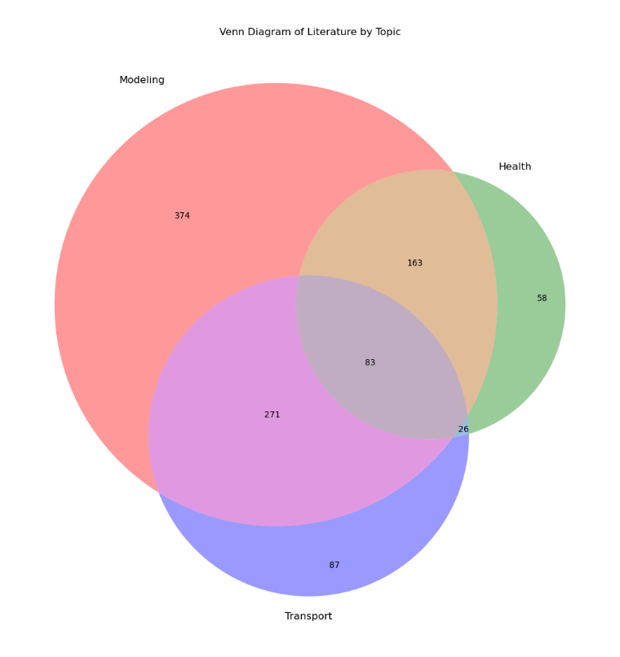

Figure 2

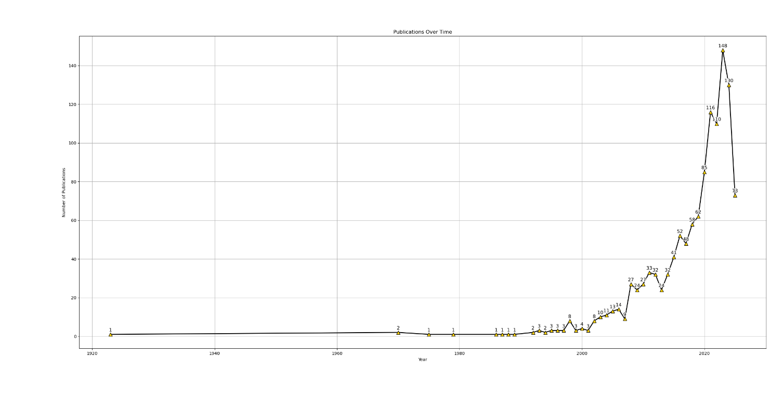 Number of research papers and publications regarding ozone overtime. The spike in literature after 1990 is representative of the historical actions described in the literature review on page ().

Figure 3

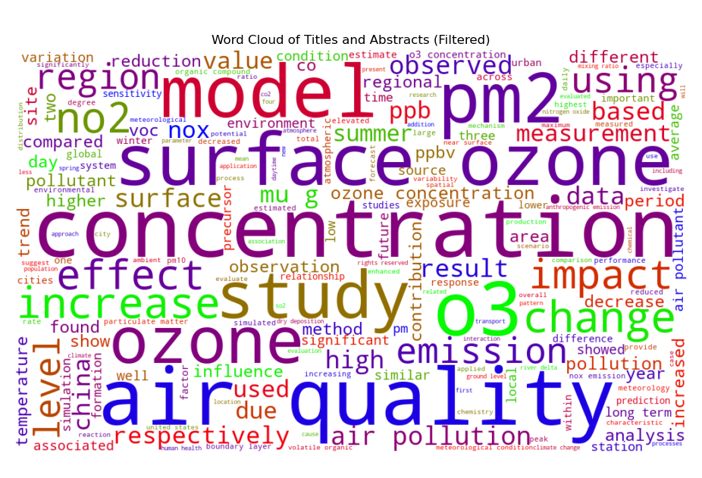Word Cloud of most frequently used words in the literature database. These words were gathered from each paper's available title and abstract to establish an overview of what was most frequently seen. While this can be assumed to encompass the most important parts of collected literature, future inspection of the literature and overall material showed a wide variety of applications and fields dedicated to ozone research.

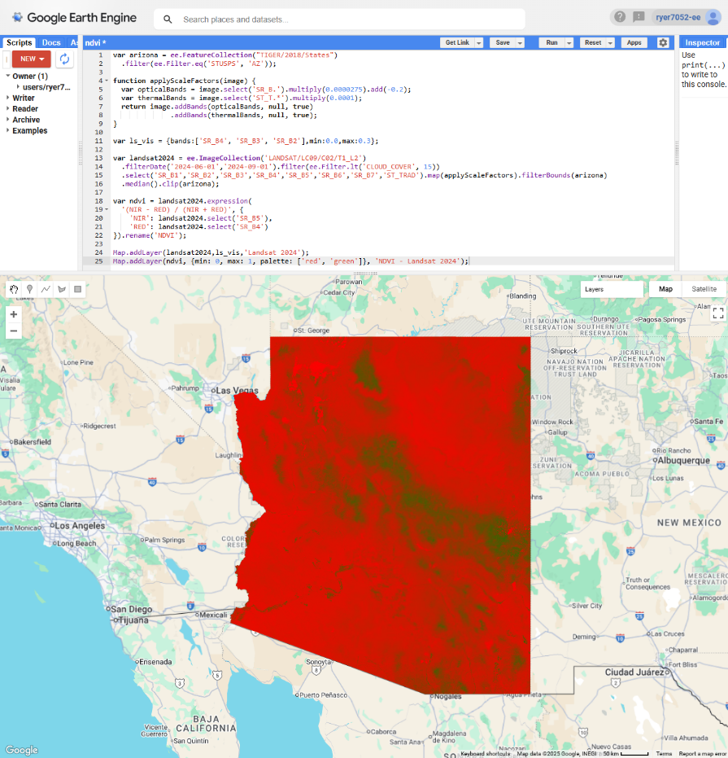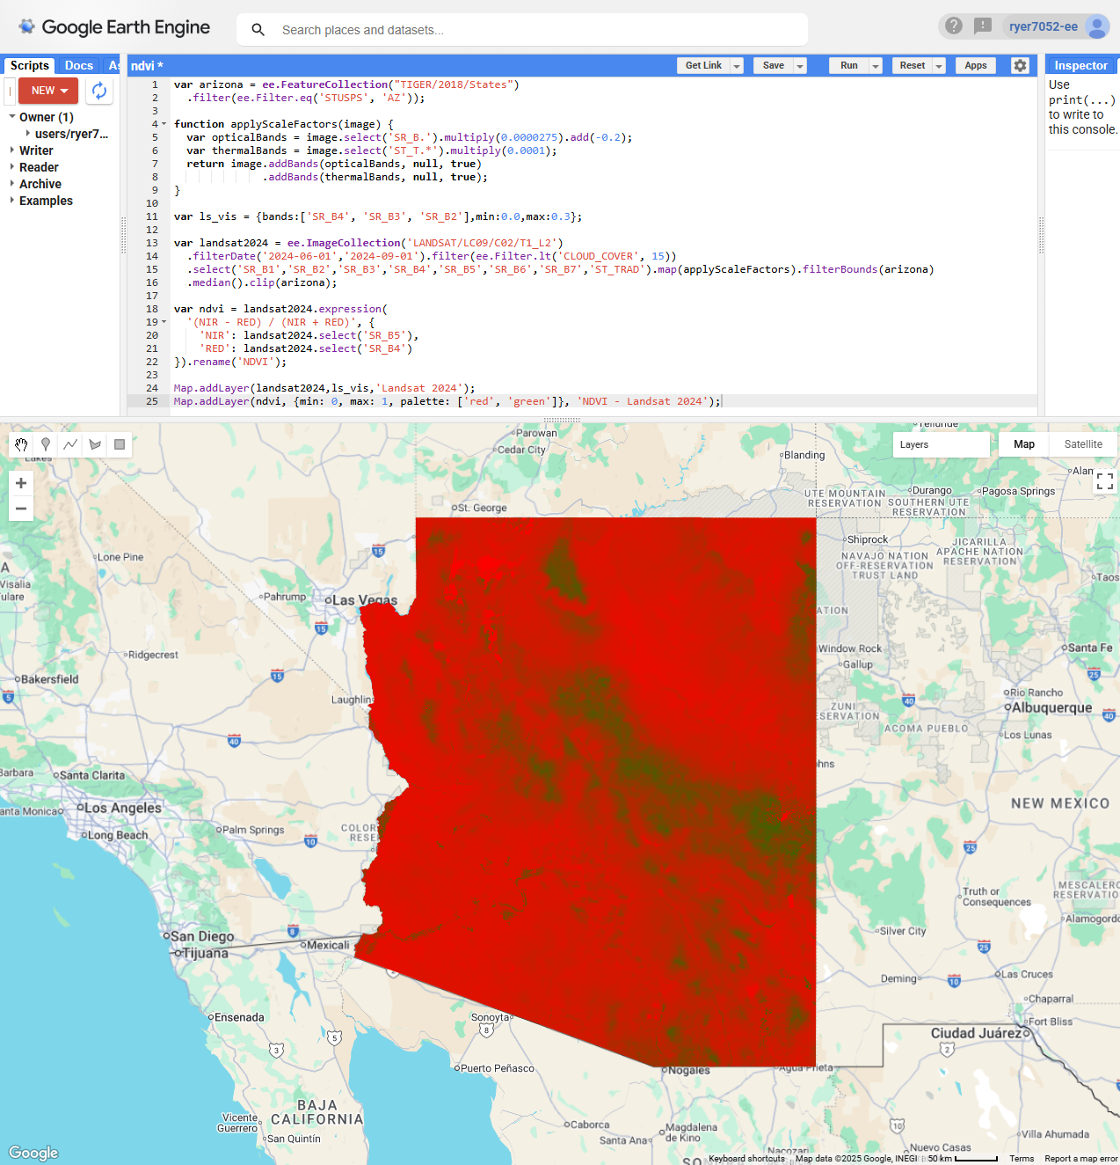

Figure 4:

The Google Earth Engine code editor GUI is based in JavaScript. NDVI is portrayed to show the ease of developing features and analyses in GEE.

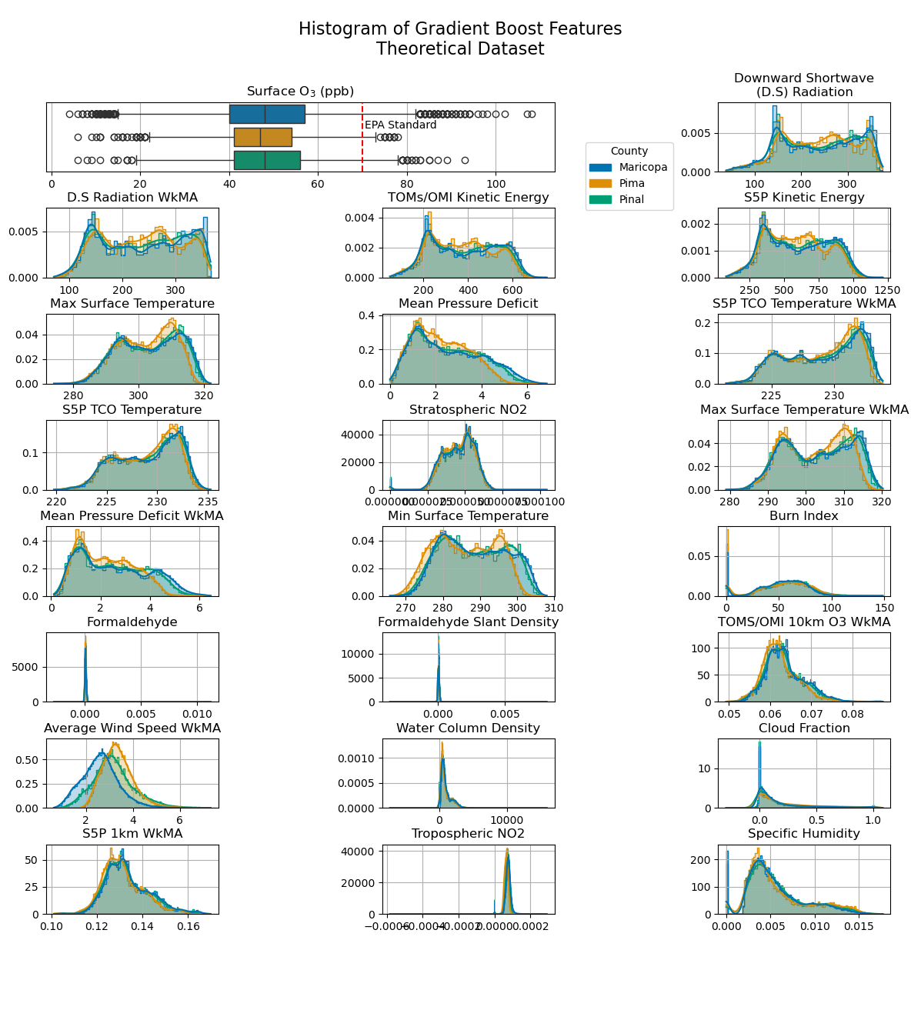Figure 5: Distribution of Features.

Figure 6: Scatterplots of Dependent vs. Independent values

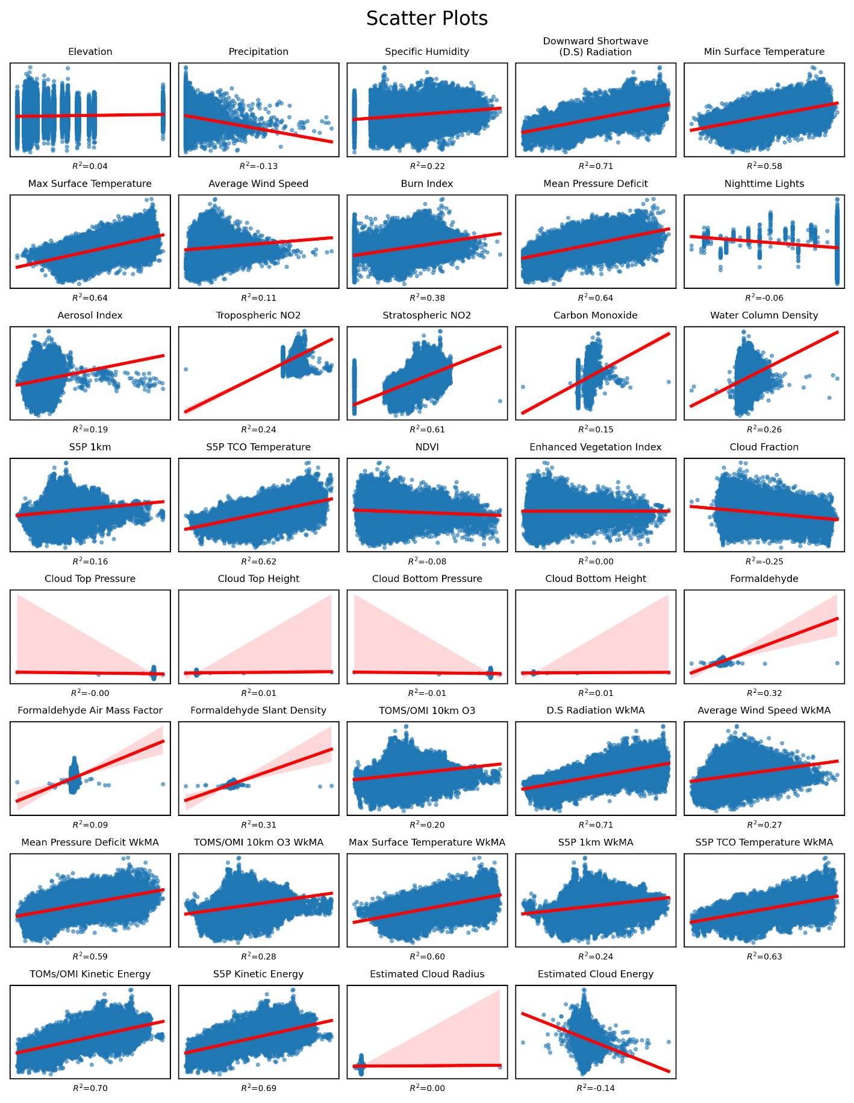

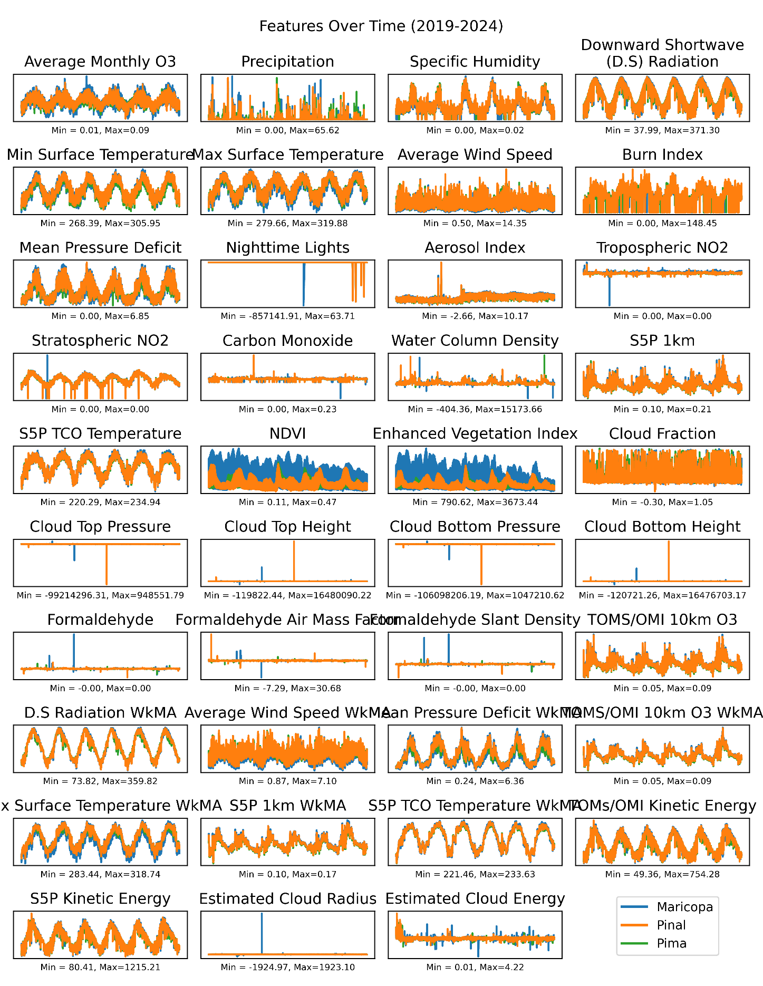Figure 7: Features split over time by county. Orange depicts consistent values across the study area. NDVI and EVI are higher in Maricopa than Pima and Pinal. Overall, larger fluctuations of the

Figure 8:

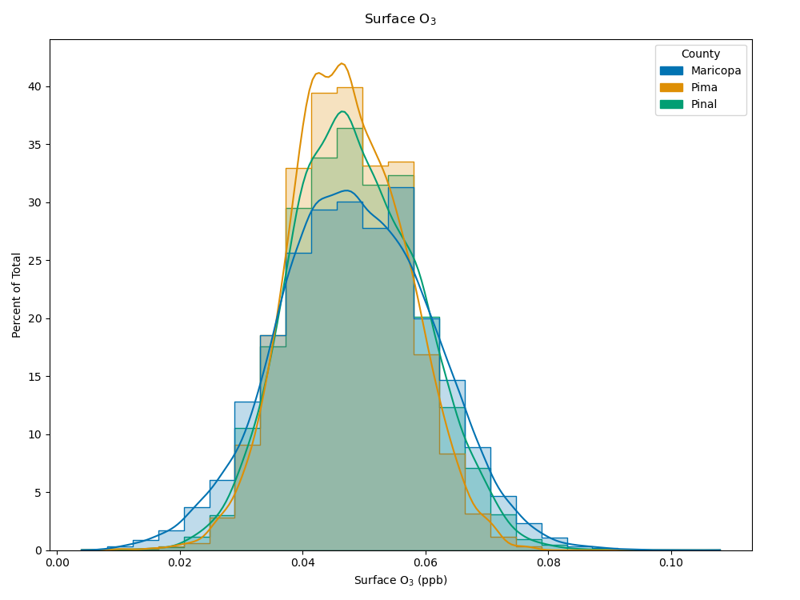Histogram of Surface O3 values at monitor locations.

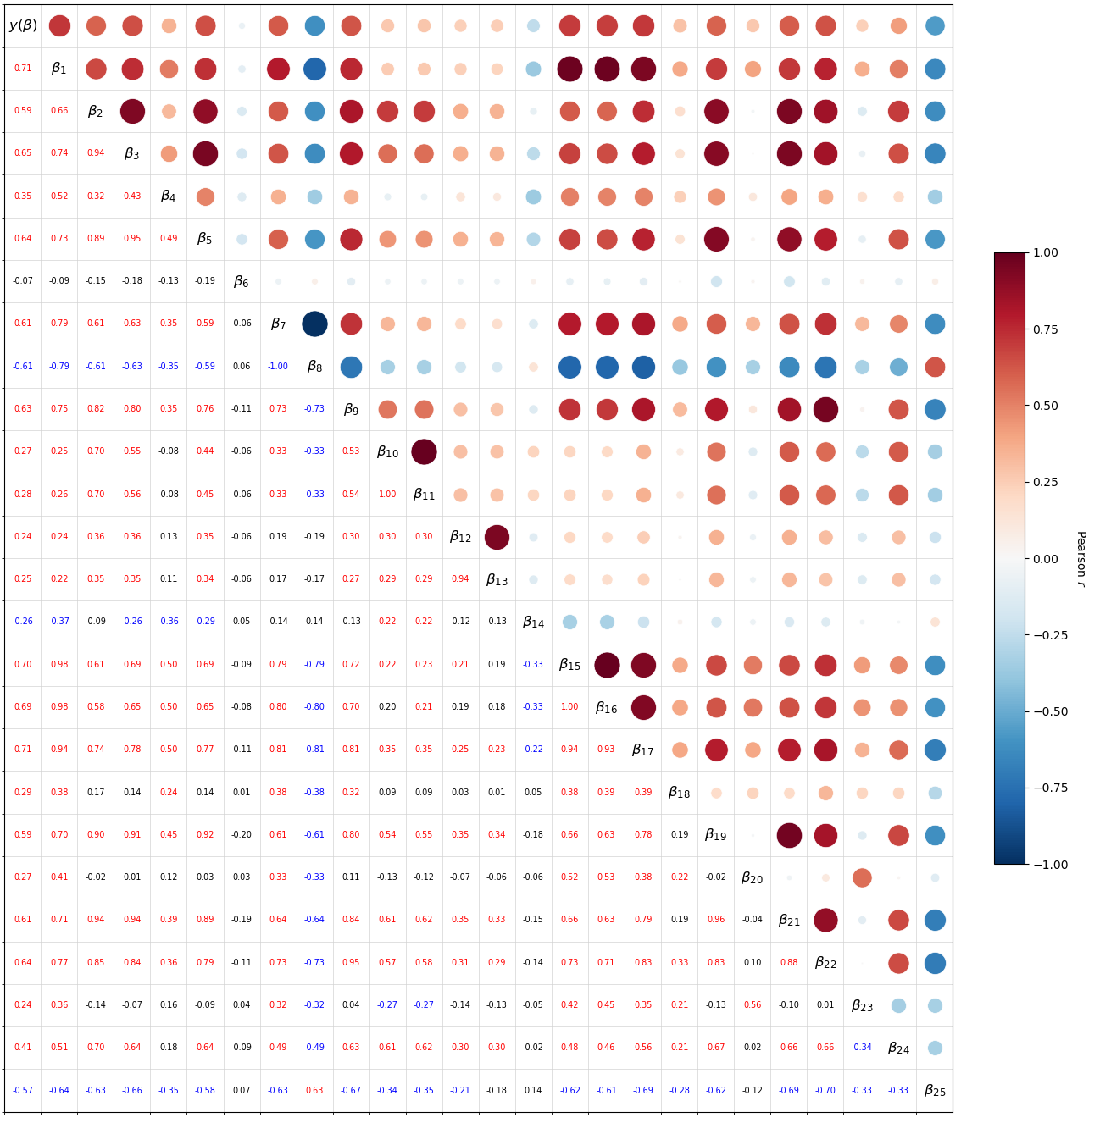

FIGURE 9

The full Pearson correlation coefficient matrix for all features used during model testing. Individual correlation matrixes that follow are for the remaining datasets. These are essentially the G.O.A.T.24 features with NDVI added to depict all 28 features used throughout each dataset. Fall was omitted from future models due to lower correlations among seasonal dummy variables.

Figure : Historical Pearson

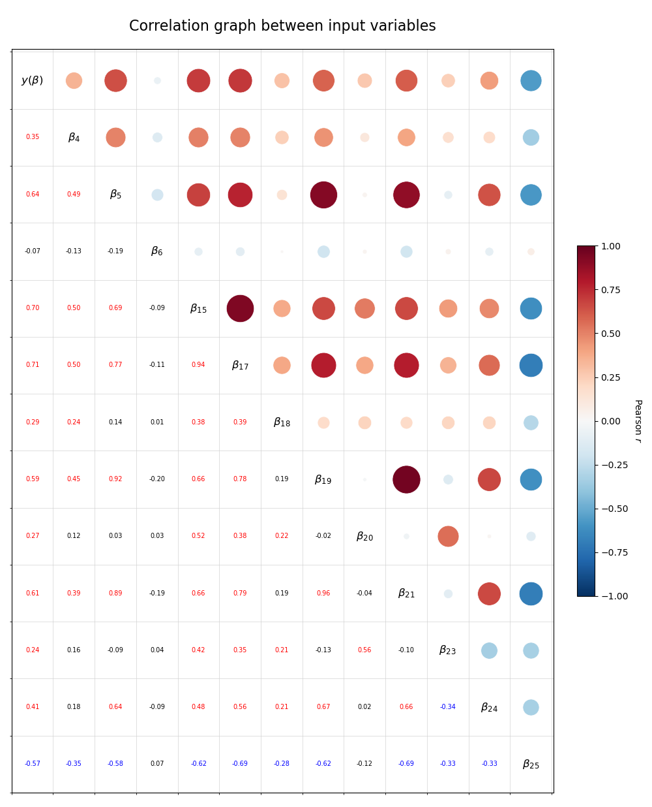

Figure : Modern Pearson

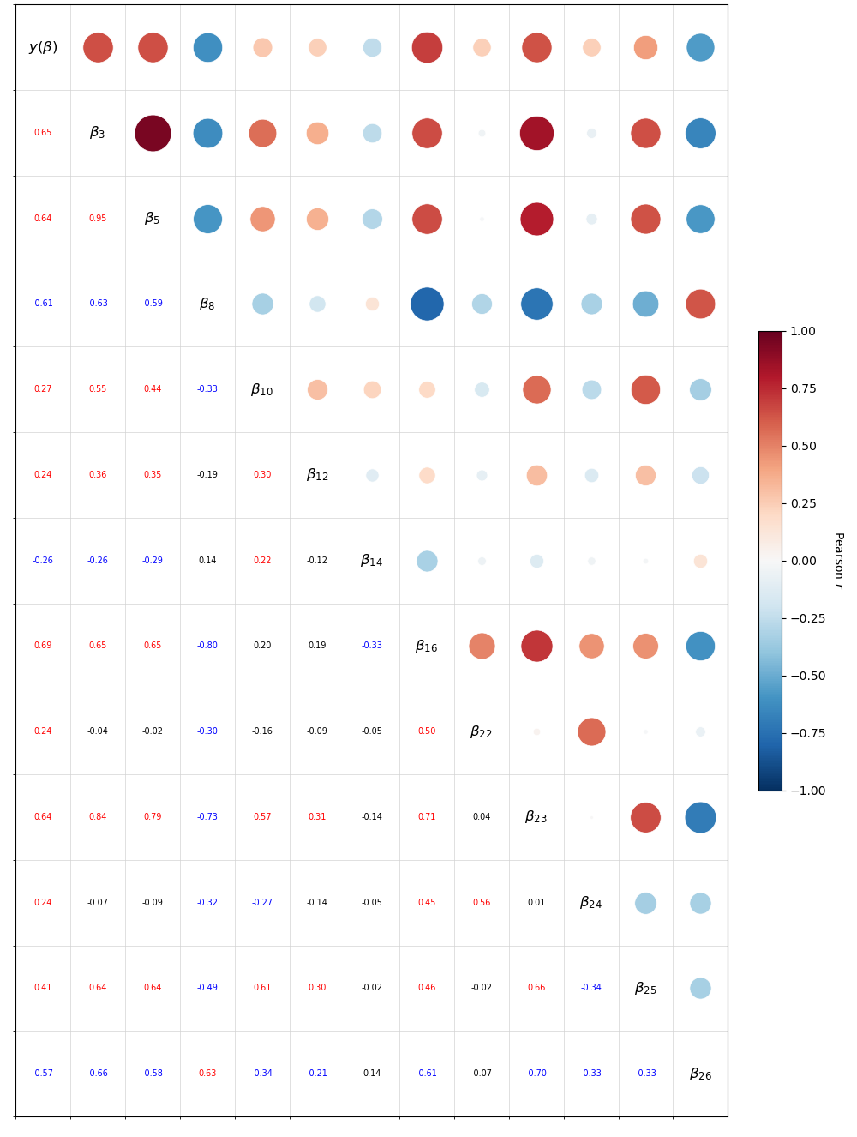

Figure : Theoretical Features, Used in Prediction

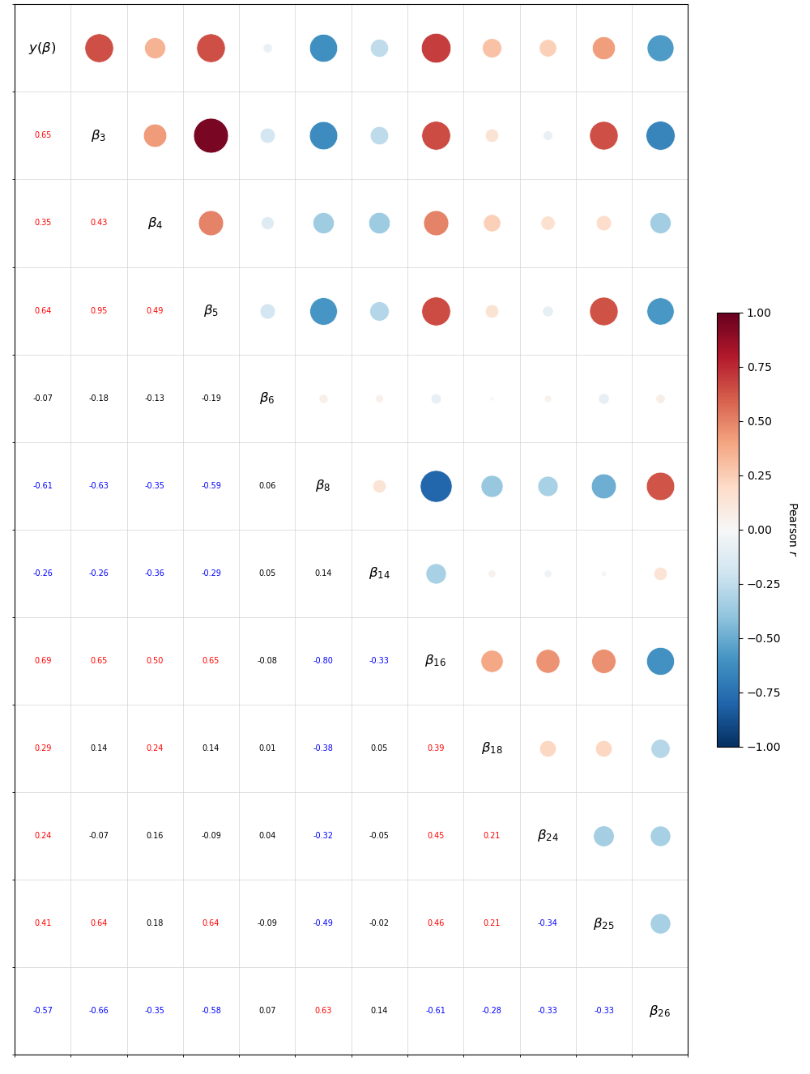

Figure : GOAT24

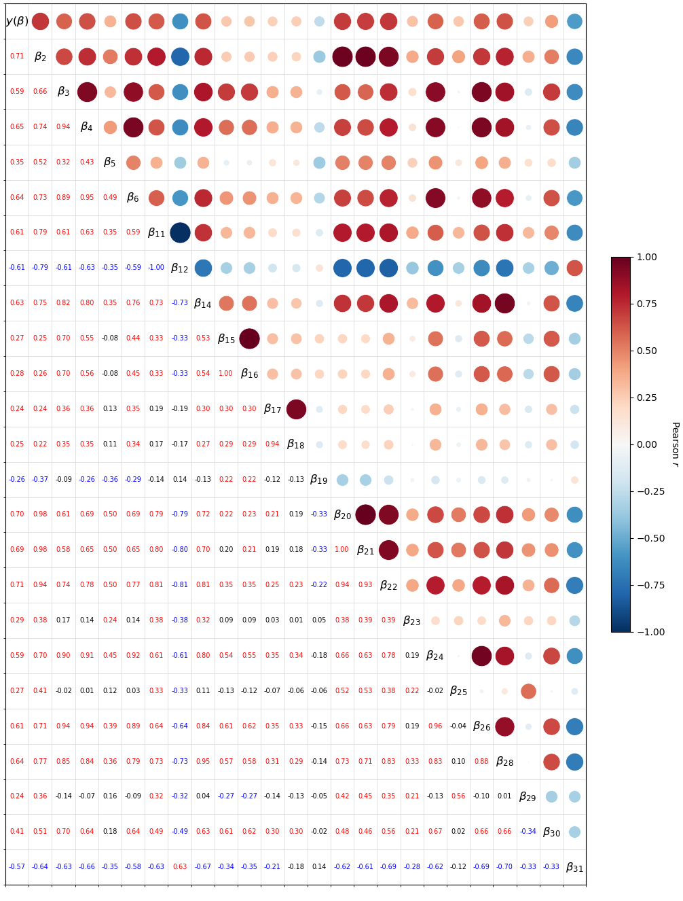

FIGURE 14

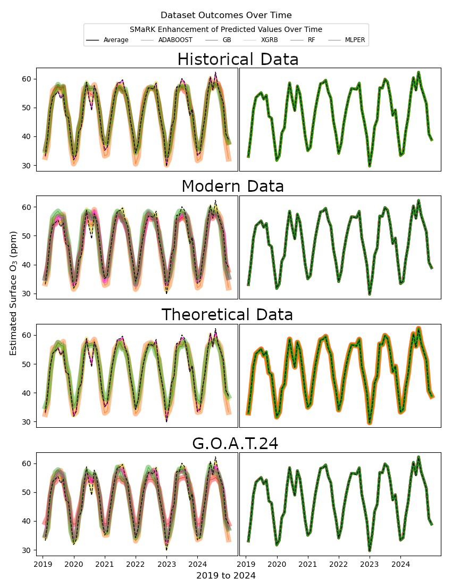All models averaged overtime per month. ML methods on the left don't always agree with the in-situ measurement.

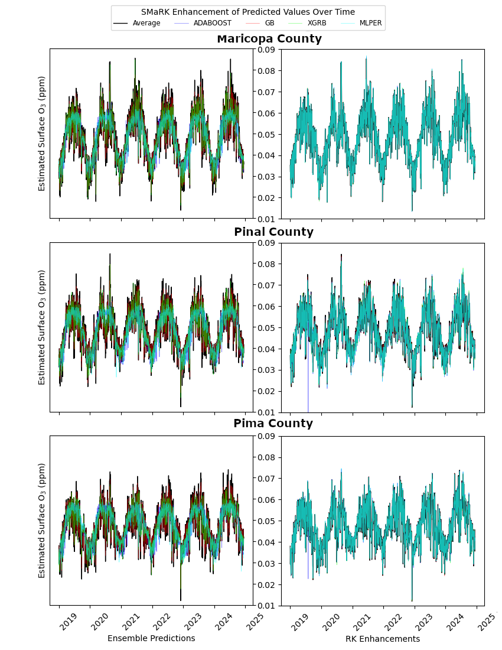

Figure 15

Surface O3 concentrations and predictions over time. Lines are split by model, statistical models in the left column have trouble depicting outliers in summer seasons. SMaRK predicted rasters vary with ground truth data much better and yielded stronger stability around seasonal trends. Ensemble methods tended to agree more with ground truth values during low seasons while failing to account for variability during high O3 seasons.

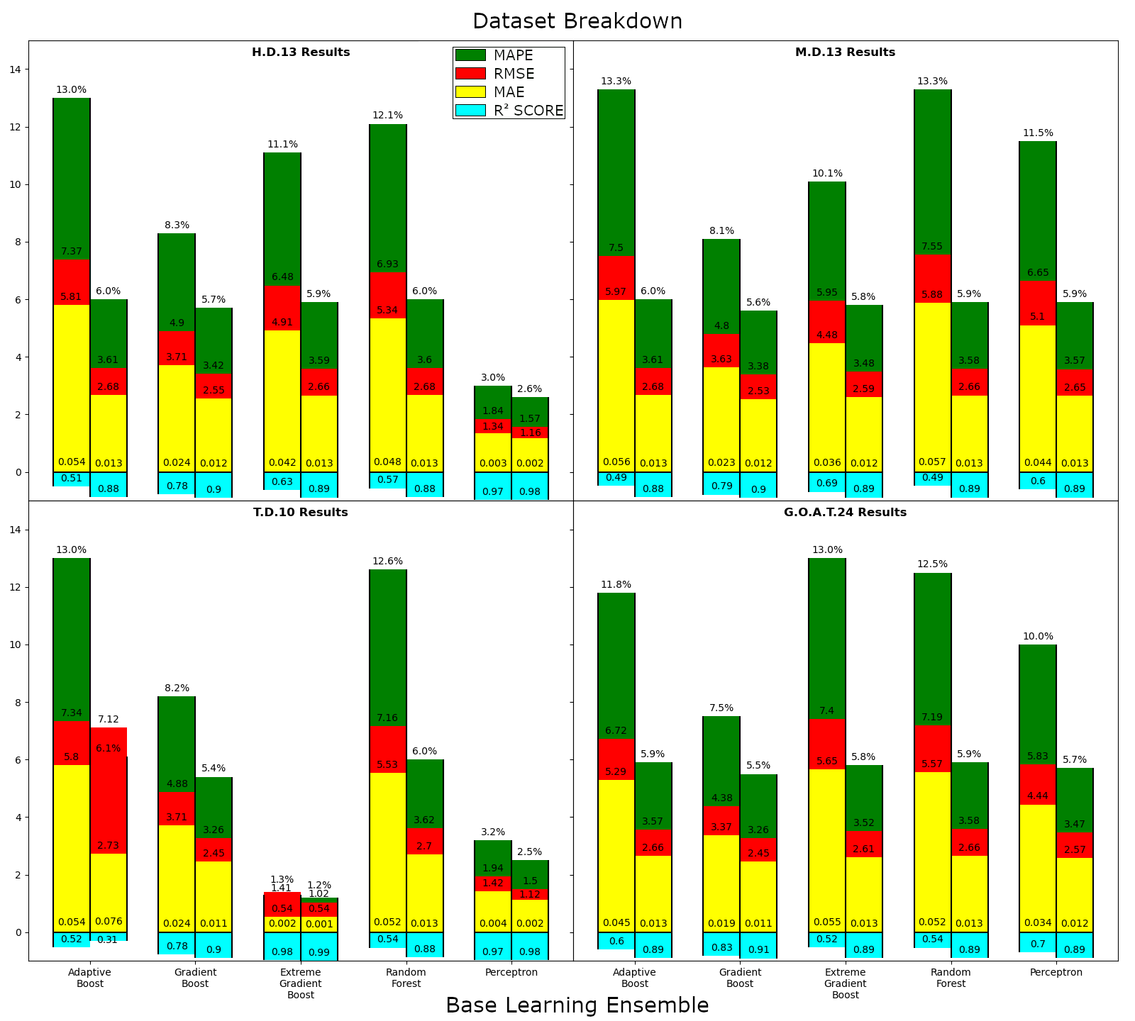

MAPS

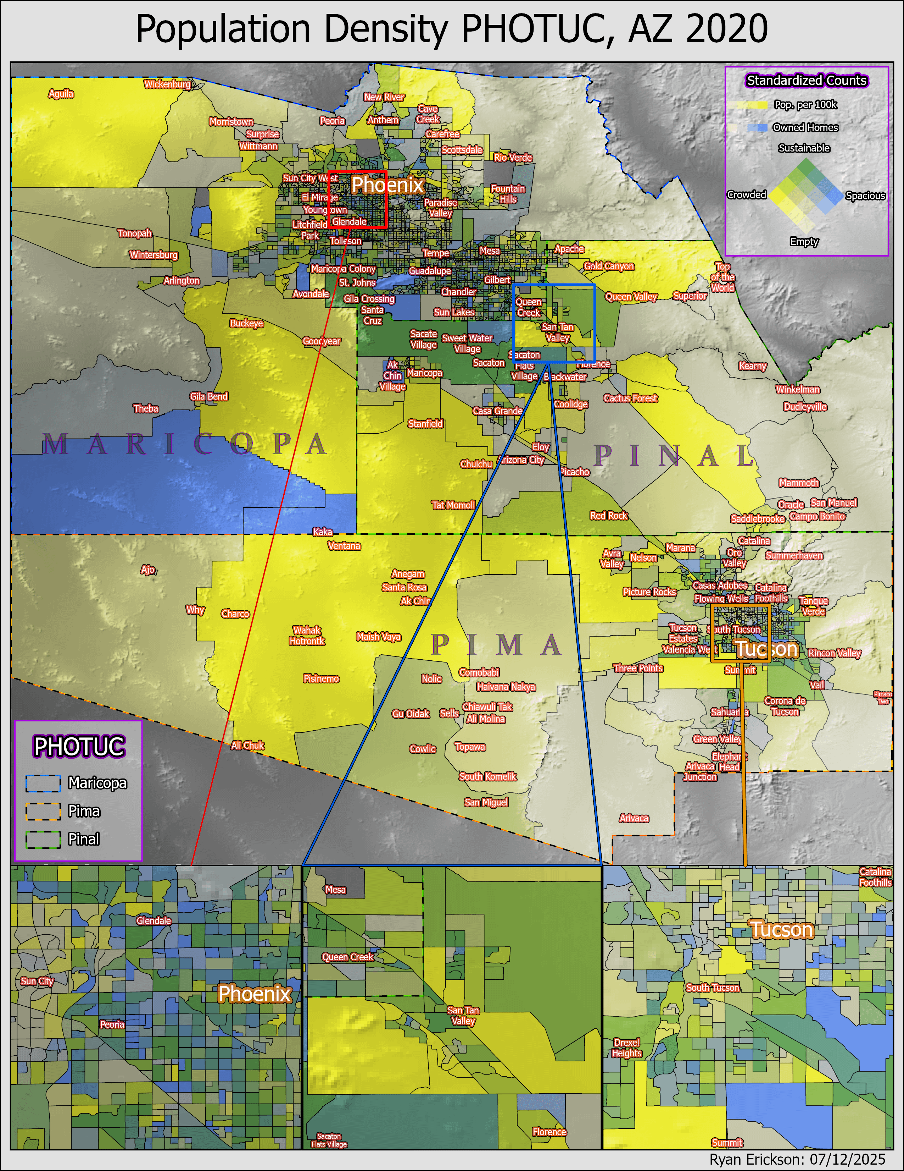

Map 1

Demographic distributions of the Pheonix and Tucson area. A bivariate color scheme is provided to depict the number of housing units and total population per census tract block group. Census data was provided by...

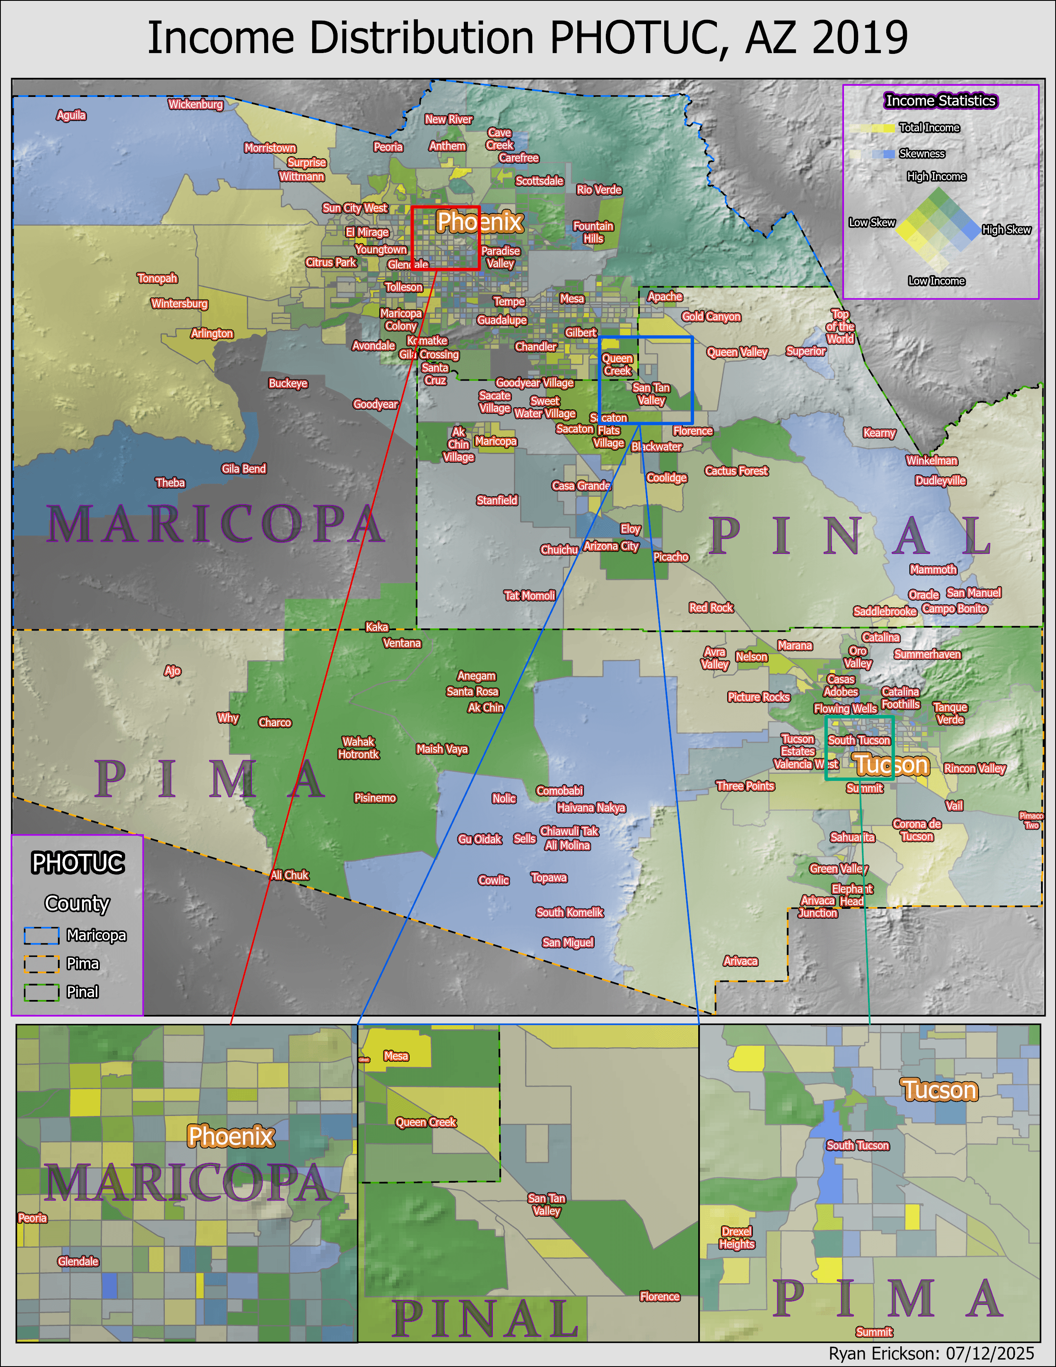Income per 100k Map

